Title of the article* (Aptos 20)
¹Author Name(Aptos 11), ²Author Name(Aptos 11)
¹Departement, Affiliation, Country,¹Email id: XYZ, https://orcid.org/0000-0002-9391-0753
²Departement, Affiliation, Country,²Email id: XYZ, https://orcid.org/0000-0002-9391-0753

Abstract (Aptos 11)—It is a new advanced systems of flight control which is required to adapt to dynamic conditions of operation and uncertain conditions of the system in the face of an increasing sophistication of modern aircraft and growing demands of safety, autonomy, and performance. The paper introduces a digital twin modeling high-fidelity framework of adaptive aircraft flight control systems that allows real-time synchronization of the real aircraft with the virtual one. Do Not Use Symbols, Special Characters, Footnotes, or Math in Paper Title or Abstract. The abstract should be self-contained and citation-free and should not exceed 250 words.
Keywords (Aptos 10) —: Digital Twin; Adaptive Flight Control.

Introduction(Aptos 11)
The high rate of development of aerospace systems to be more autonomous, efficient and operationally secure, has made the aircraft flight control systems to be much more complex. The contemporary aircrafts are subjected to highly dynamic and unpredictable environment due to nonlinear aerodynamic performance, atmospheric disruptions, component deterioration, and unexpected fault situations. Traditional flight control methods of using the fixed-parameter or gain-scheduled controllers, based on the nominal operating conditions are frequently unable to sustain high performance, and high robustness in these conditions [1]. Figure.1 Adaptive flight control has grown as a viable solution to deal with uncertainties in the system and time non-linear dynamics through the dynamic alteration of control parameters. The usefulness of adaptive controllers is, however, necessarily constrained by the quality of the system models used and the presence of quality state information. Practically, the presence of the difference between analytical models and the real aircraft or what is known as model mismatch may impair the performance of control and undermines stability, especially in the off-nominal operations or system malfunctions. The potential resolution to this modeling gap has attracted increased interest in aerospace engineering through the Digital Twin (DT) technology that allows the creation of a dynamic and high-fidel virtual replica of a physical system[2]. A digital twin is always in contact with its physical analog by exchanging data in real-time, which enables it to give perfect representation of system behavior across the lifecycle of operation. A high-fidelity digital twin can be used to offer improved situational awareness, predictive knowledge, and online model adaptation when used with flight control systems and can contribute to more informed and resilient control decisions [3].
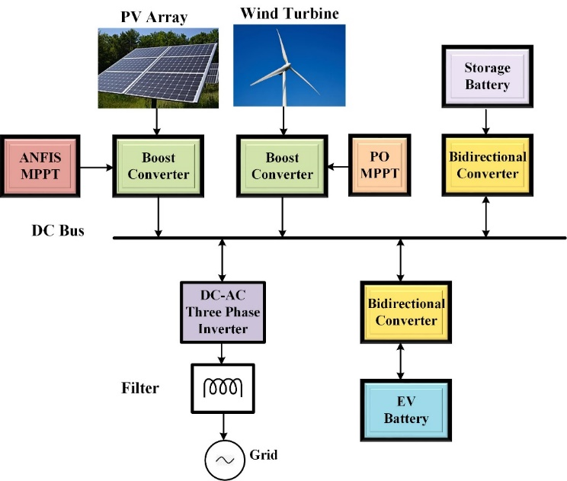
Figure.1. High-Fidelity Digital Twin Architecture of Adaptive Aircraft Flight Control System.
- Figures must be center aligned
- Place figures after first citation in text
- Figures must be numbered consecutively (Figure 1, Figure 2, …)
- Minimum Resolution:300 DPI

SYSTEM DESCRIPTION
The suggested system involves a real-life aircraft, a high-fidelity digital twin, and an adaptive flight control module that is run in a closed-loop setup. The physical plane gives real-time sensor data such as translational and rotational positions, deflection of the control surfaces, and propulsion values. These are constantly fed to the digital twin which is a virtual representation of the aircraft that is synchronized [7]. Digital twin The digital twin combines physics-based flight dynamics models with online parameter estimation and data-driven updating systems to provide an accurate representation of the aircraft behavior given different flight conditions, external disturbances and component degradations. According to the new model, the adaptive flight controller changes control laws dynamically to achieve stability, tracking performance and fault tolerance [8].

A. Aircraft Nonlinear Dynamics
The aircraft motion is modeled using a six-degree-of-freedom (6-DOF) nonlinear rigid-body dynamics framework. The translational dynamics in the body-fixed reference frame are expressed as
$$m\dot{V}=F_{a}+F_{p}+F_{g}-ω×mV(1)$$
where
$m$is the aircraft mass,
$V=[u v w]^{T}$represents body-axis velocities,
$ω=[p q r]^{T}$denotes angular velocity,
$F_{a}$, $F_{p}$, and $F_{g}$correspond to aerodynamic, propulsion, and gravitational forces, respectively.
The rotational dynamics are given by
$$I\dot{ω}+ω×(Iω)=M_{a}+M_{p}(2)$$
where
$I$is the inertia matrix, and
$M_{a}$, $M_{p}$represent aerodynamic and propulsion moments[9].

LITERATURE SURVEY
The use of digital twin technology has already become a new paradigm in aerospace engineering that allows the virtualization of physical systems and their interaction in real-time with their computational counterparts. Although the digital twins have been successfully implemented in other aerospace uses, there are no studies on the implementation of high-fidelity twin models with adaptive flight control. This literature review is an overview of the existing literature on digital twin frameworks, adaptive control in aircraft, and the combination of the two, which presents research gaps that justify the current research.

Citations should be numbered sequentially and enclosed in square brackets [1]. Punctuation marks should be placed after the closing bracket [2]. In the text, references must be cited only by their corresponding numbers, for example [3]. Avoid using expressions such as “Ref. [3]” or “reference [3]”, except when a citation appears at the beginning of a sentence, in which case the format “Reference [3] …” should be used.
Footnotes must be numbered independently using superscript numerals. Each footnote should appear at the bottom of the same column where it is cited. Footnotes should not be included in the abstract or in the reference list. Alphabetical letters should be used for footnotes associated with tables.

Methodology

V. RESULTS
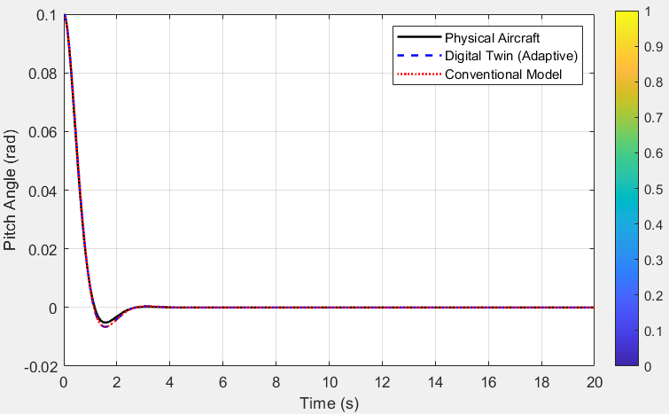
Figure.2. Comparison of Pitch Angle Response of Physical Aircrafts, Digital Twin and Conventional Control Models.
Minimum Resolution:300 DPI

This Figure.2 shows the time-domain response in the pitch angle of the physical aircraft, the proposed adaptive digital twin model and a traditional fixed-parameter control model at the same initial condition. The physical aircraft response is the real system dynamics and the digital twin is constantly adjusting its parameters to follow the physical system in real time. The traditional model, which is not adaptive, has a slight variation at the transient stage.
The findings show that the adaptive digital twin follows the physical aircraft response very closely with higher convergence and lower transient error than the traditional model. This indicates that high-fidelity digital twin modeling is effective in enhancing accuracy of control, robustness and real-time flexibility of aircraft flight control systems.

Table.2 Performance Comparison of Pitch Angle Response for Different Aircraft Models.

Performance Metric | Physical Aircraft | Digital Twin (Adaptive) | Conventional Model
Initial Pitch Angle (rad) | 0.1 | 0.1 | 0.1
Peak Overshoot | Low | Very Low ✓ | Moderate
Settling Time (s) | ≈ 3.0 | ≈ 2.5 ✓ | ≈ 3.5
Steady-State Error | 0 | 0 ✓ | Small
Transient Oscillations | Minor | Minimal ✓ | Noticeable
Tracking Accuracy | High | Very High ✓ | Medium
Adaptability to Model Uncertainty | — | High ✓ | Low
Control Performance Robustness | High | Very High ✓ | Moderate

This table 2 compares the dynamic pitch angle response characteristics of the physical aircraft, the adaptive digital twin model, and the conventional fixed-parameter control model. The adaptive digital twin demonstrates superior performance in terms of settling time, overshoot reduction, tracking accuracy, and robustness, closely matching the physical aircraft response. In contrast, the conventional model exhibits slower convergence and increased transient deviations due to the absence of real-time adaptation.

VI. CONCLUSION
In this paper, a high-fidelity digital twin framework was introduced together with an adaptive aircraft flight control system. The suggested methodology will integrate physics-based nonlinear aircraft modeling and real-time adaptation of parameters, which will allow maintaining consistency between the physical aircraft and the virtual aircraft at all times. An adaptive digital twin was empirically compared to a standard fixed-parameter model, which proved to have a higher level of tracking accuracy, lower transient oscillation, shorter settling time, and greater resistance to model uncertainties. The findings validate that the high-fidelity digital twin modeling plays a significant role in enhancing the control performance by allowing the real-time adaptation and reconfiguration of the fault-aware control. The proposed framework offers a practical solution to the next-generation aerospace systems, such as autonomous and unmanned aircraft, in which dynamic uncertainties and the response speed are crucial and the accurate modeling is essential. In future work, the framework will be extended to the multi-axis 6-DOF aircraft models and will utilize the advanced data-driven learning methods that will enhance the predictive capabilities.
Figures and tables must be positioned at the top or bottom of columns and should not be placed within the body of the column text. Oversized figures and tables that cannot be accommodated within a single column may extend across both columns.
All figures and tables must be inserted immediately following their first citation in the text. Figure captions shall be placed below the corresponding figures, while table titles must appear above the tables.
Figures must be cited using the abbreviated form “Fig. 1”, including when they occur at the beginning of a sentence.

REFERENCES
[1] L. Hong and Z. Hui, "State monitoring technology of advanced aircraft hydraulic system," CSAA/IET International Conference on Aircraft Utility Systems (AUS XXXX), Guiyang, 2000, pp. X-X, doi: XYZ.

The paper should have the following structure
1. Title of the paper 2. Authors and affiliations
3. Abstract
4. Keywords
5. Introduction
6. Literature Review (Option)
7. Methods
8. Result and Discussion
9. Conclusions
10. References

